1. Create a bucket

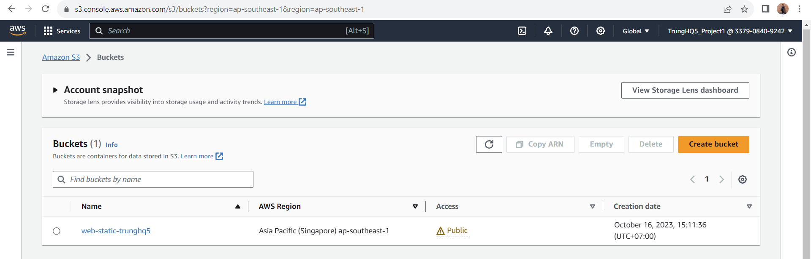

1. Upload file and folder to s3 bucket

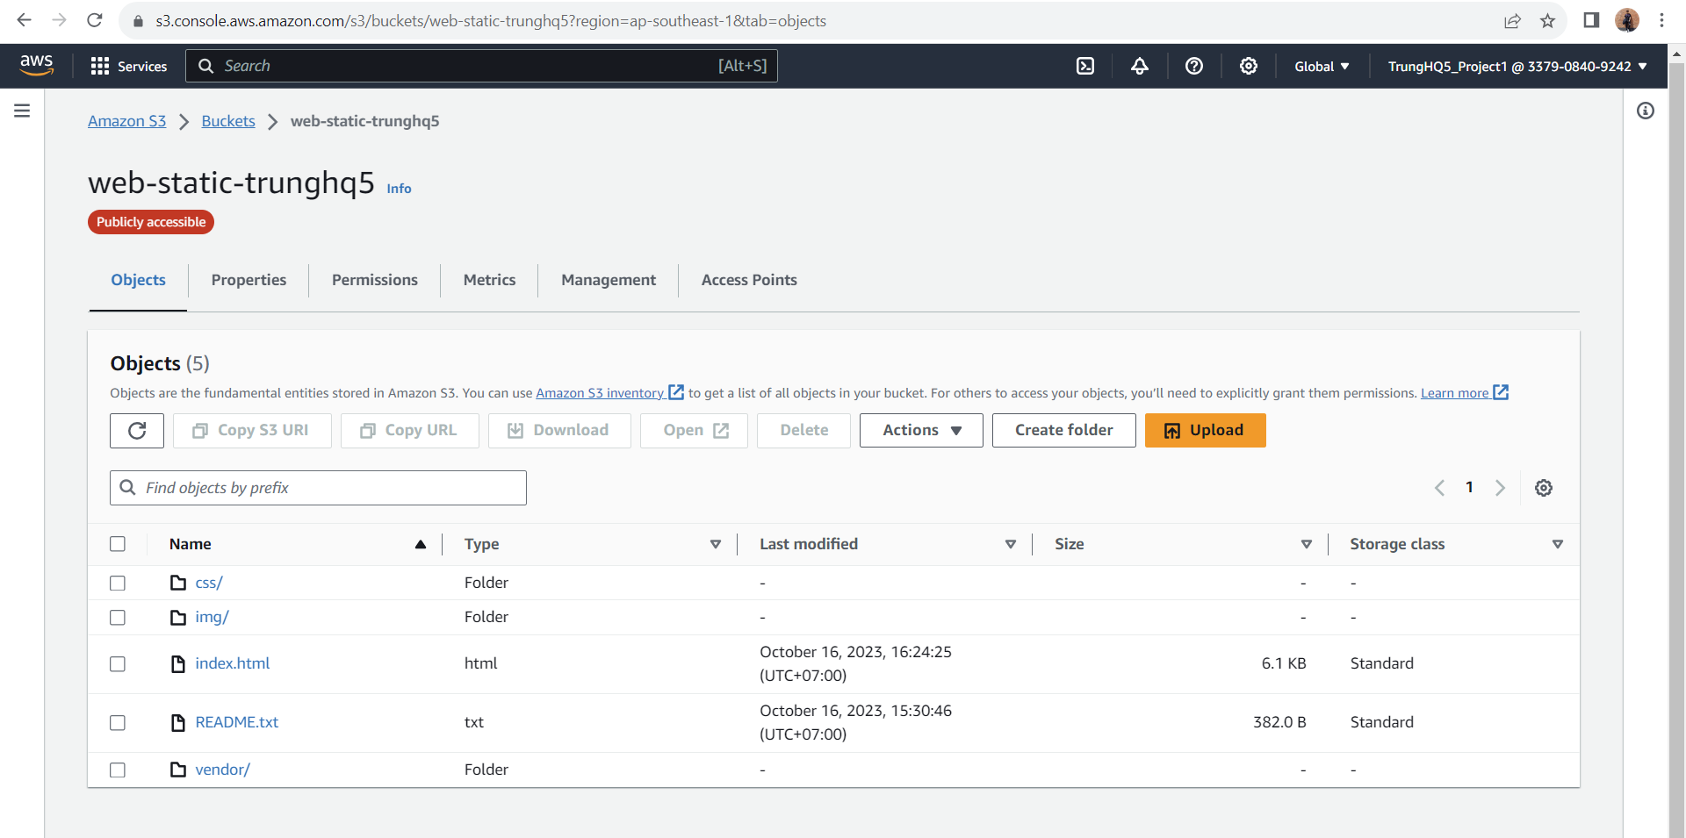

1. Secure bucket via iam

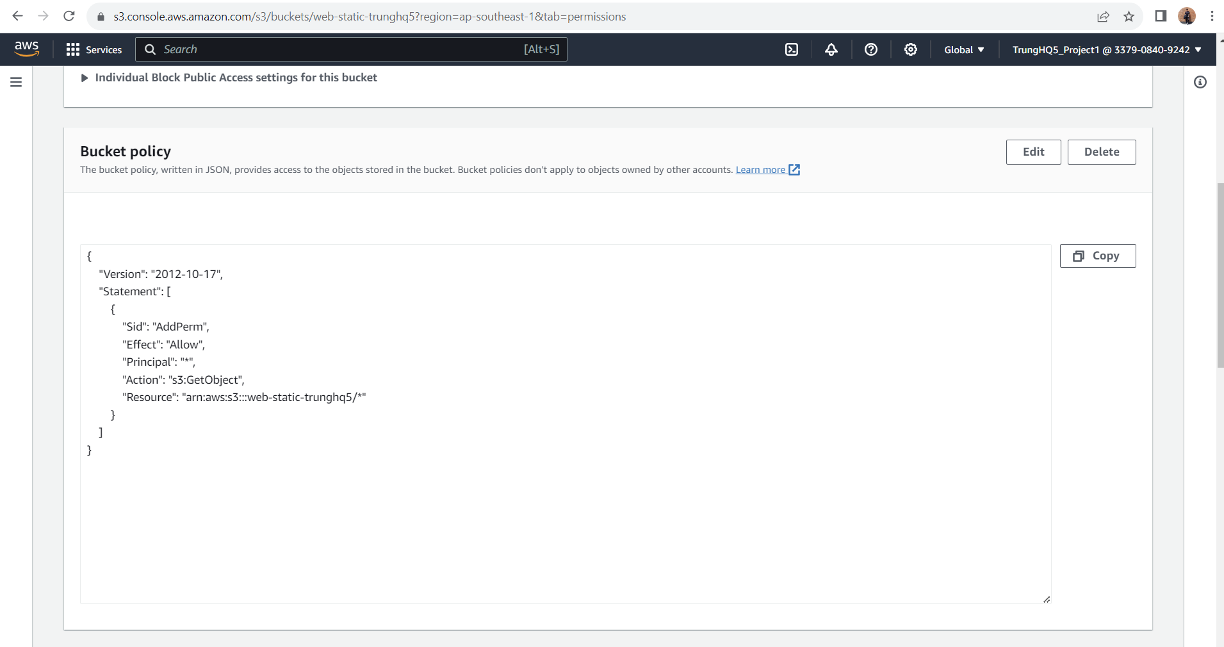

1. Config S3 bucket

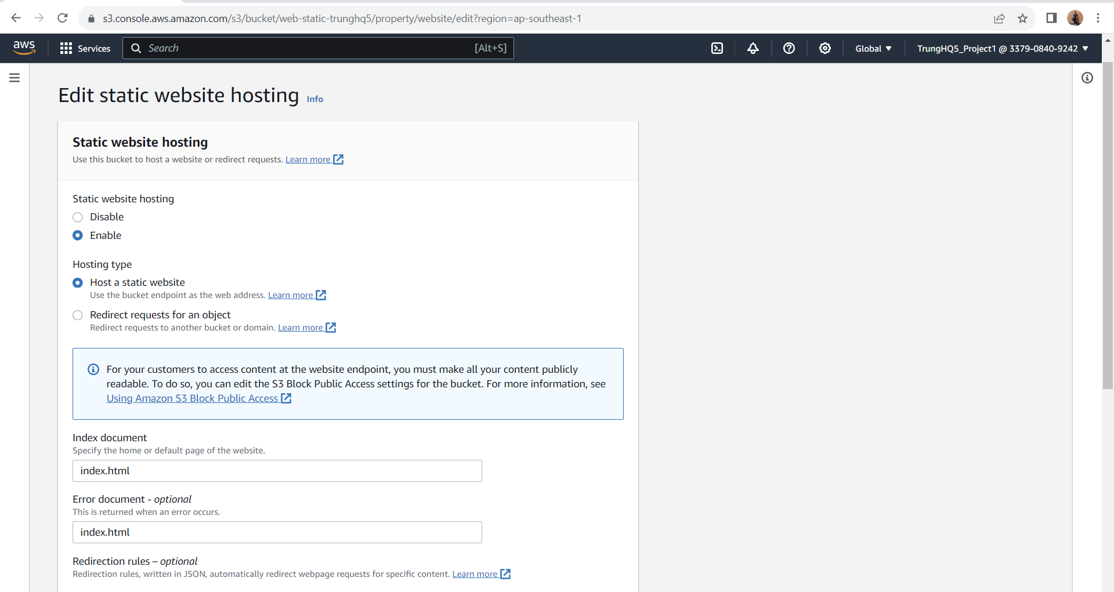

Bucket website endpoint

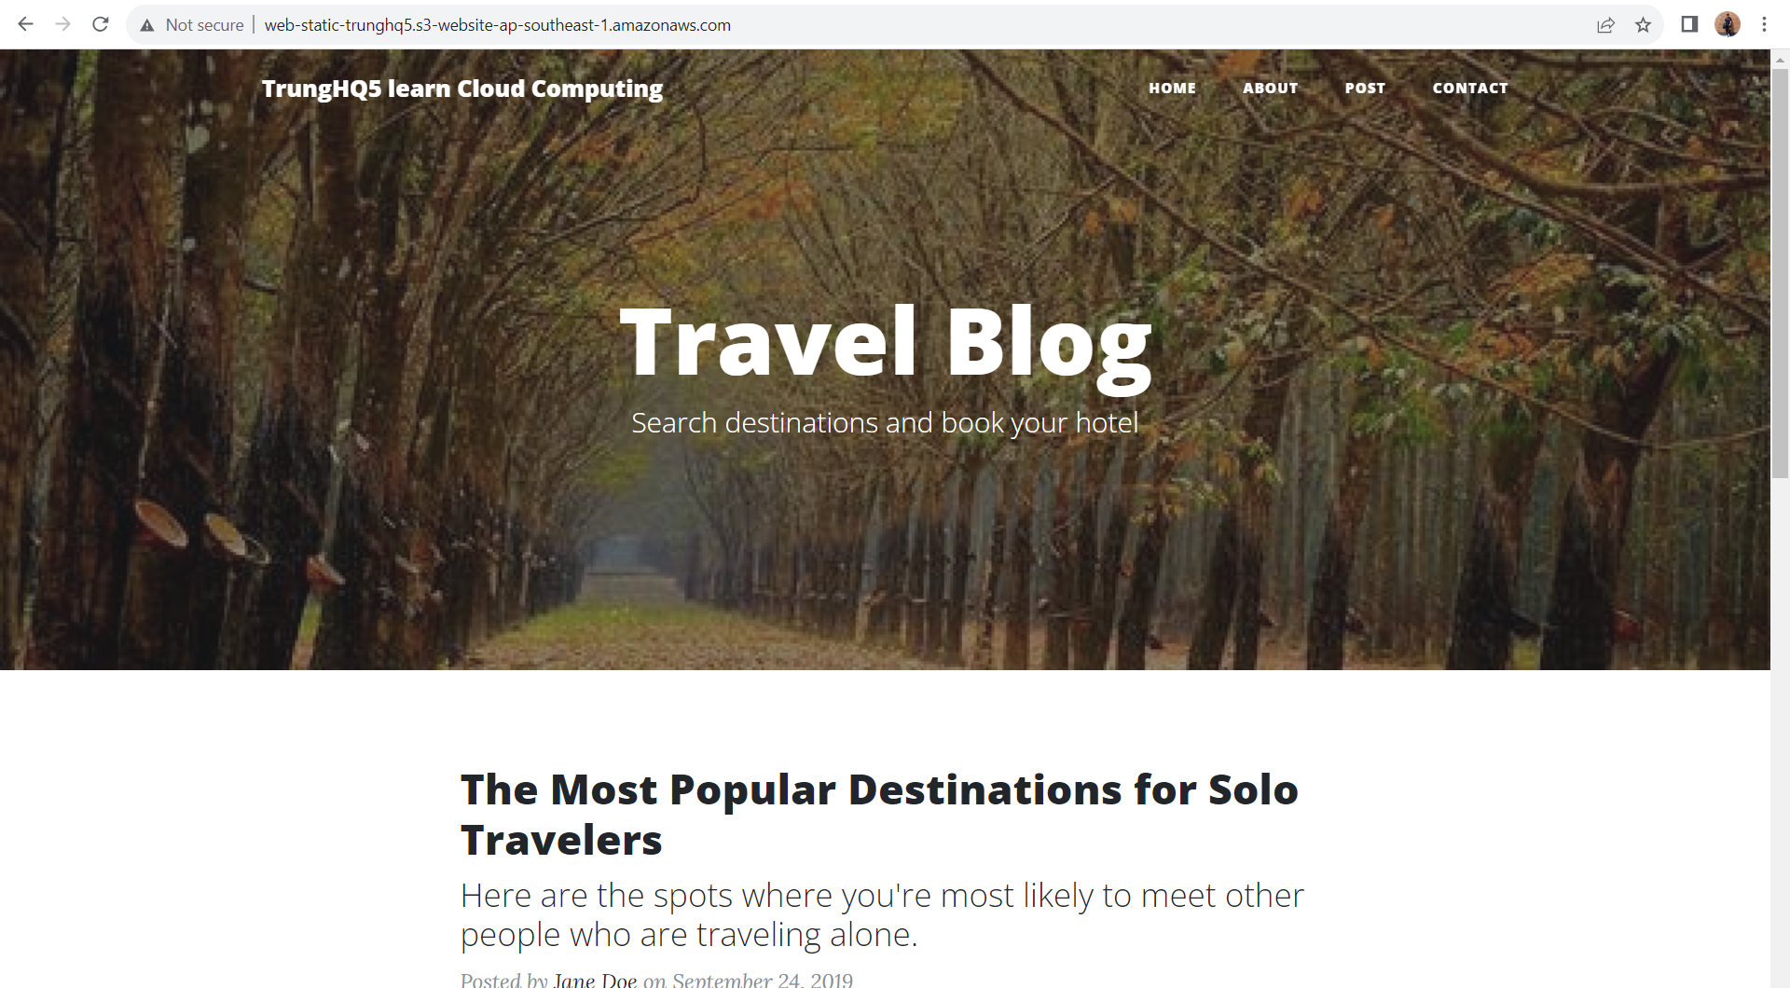

1. Distribute website via Cloud Front  
   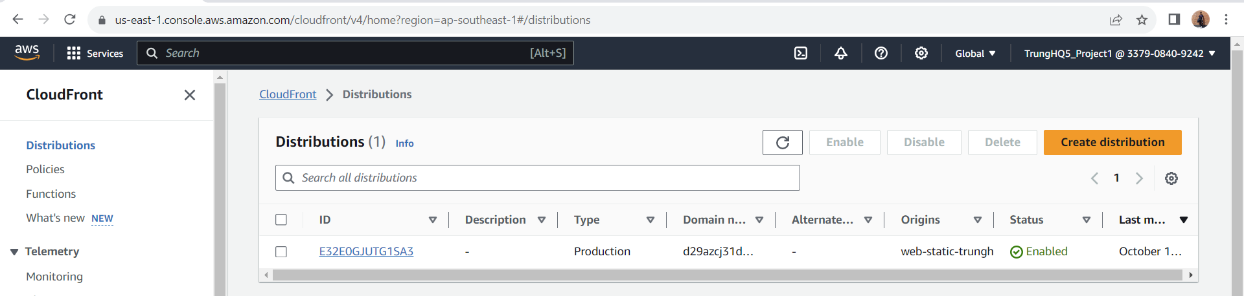
2. Access website in web browser

Cloud front:



Access website via website endpoint:

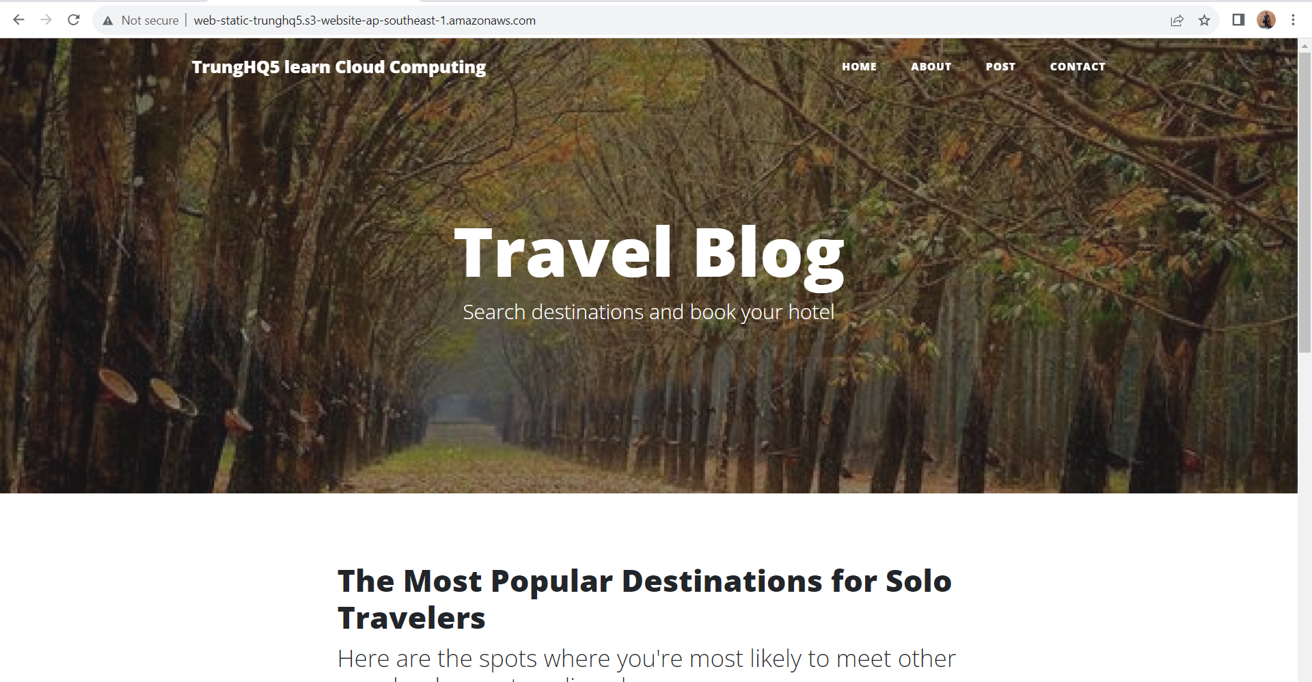

Access the bucket object via its S3 object url :

